**3BM1 Revision II （3.25）讲义**

1. **ch [ tʃ ] Charlie has a chick. Charlie has a chair. Chair and his chick are sitting on the chair. 圈出ch[ tʃ ]的单词**
2. **sh [ ʃ ] I can see a shop. I can see the ships. How many ships in the shop? One, two, three, four, five, six. Come and see the six ships in the shop. 圈出sh [ ʃ ]的单词**
3. **wh [ w ] What can you see in the photograph? I can see Mr White. I can see his toy whale and its white tail. 圈出wh [ w ]的单词**
4. **title(标题)**
5. **cover(封面)**
6. **author(作者)**
7. **能够朗读绘本，发音正确、朗读流利，注意语音语调。朗读包括标题和作者。**

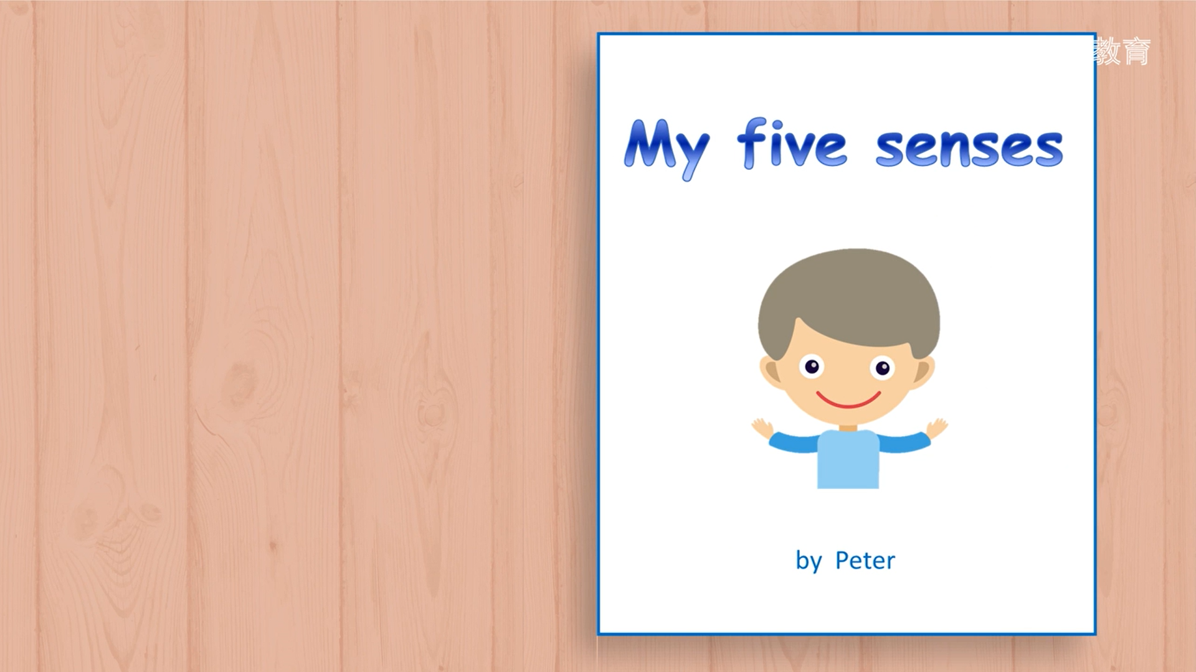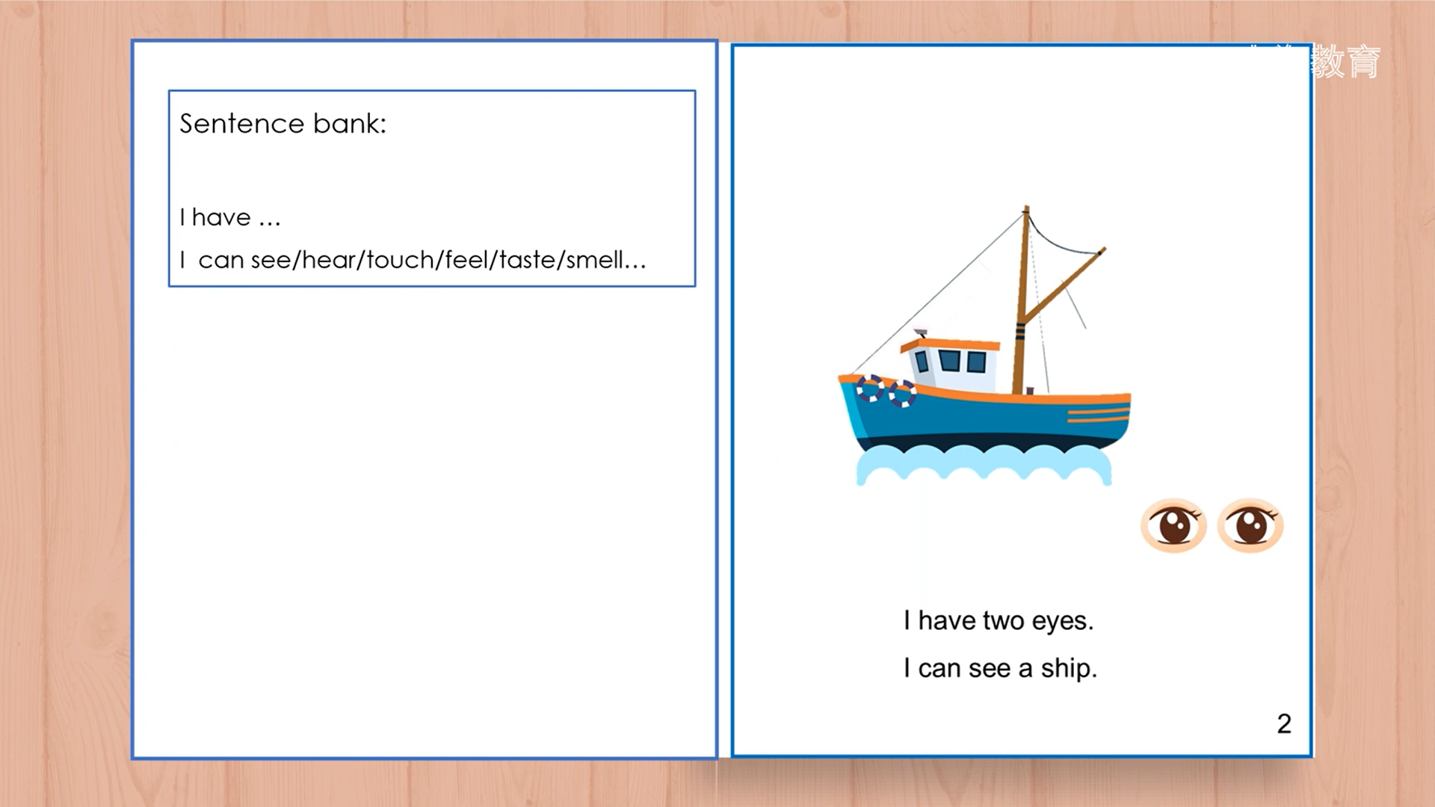

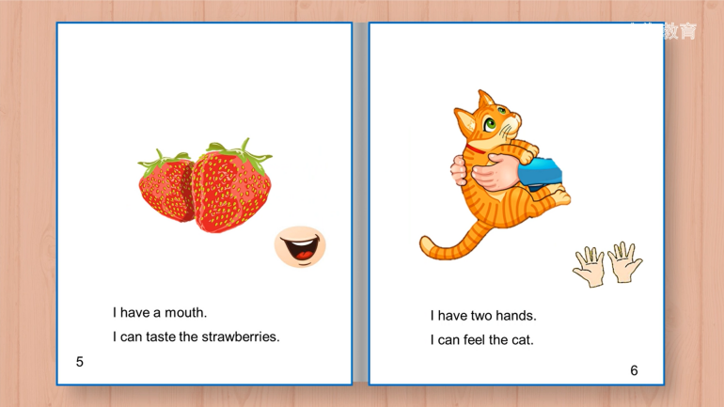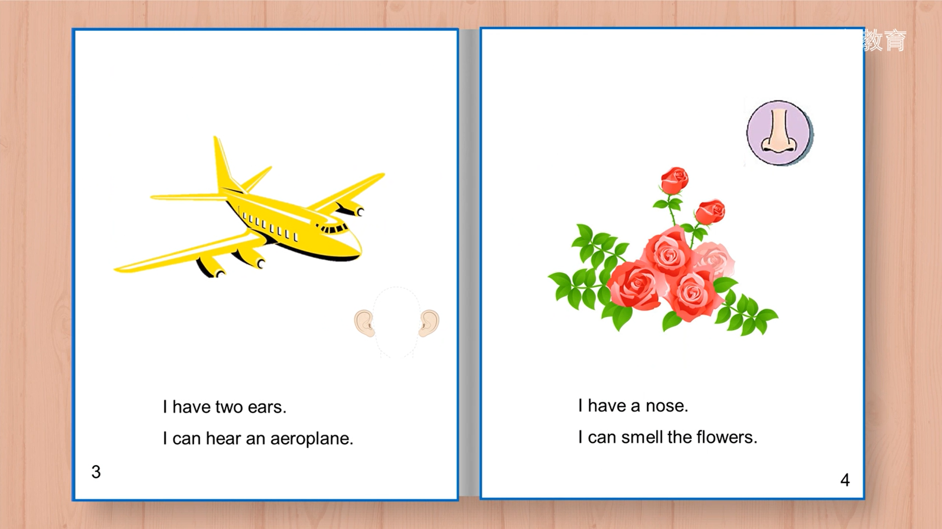

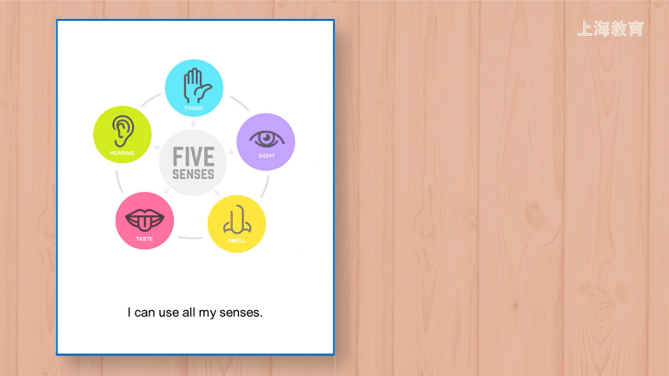

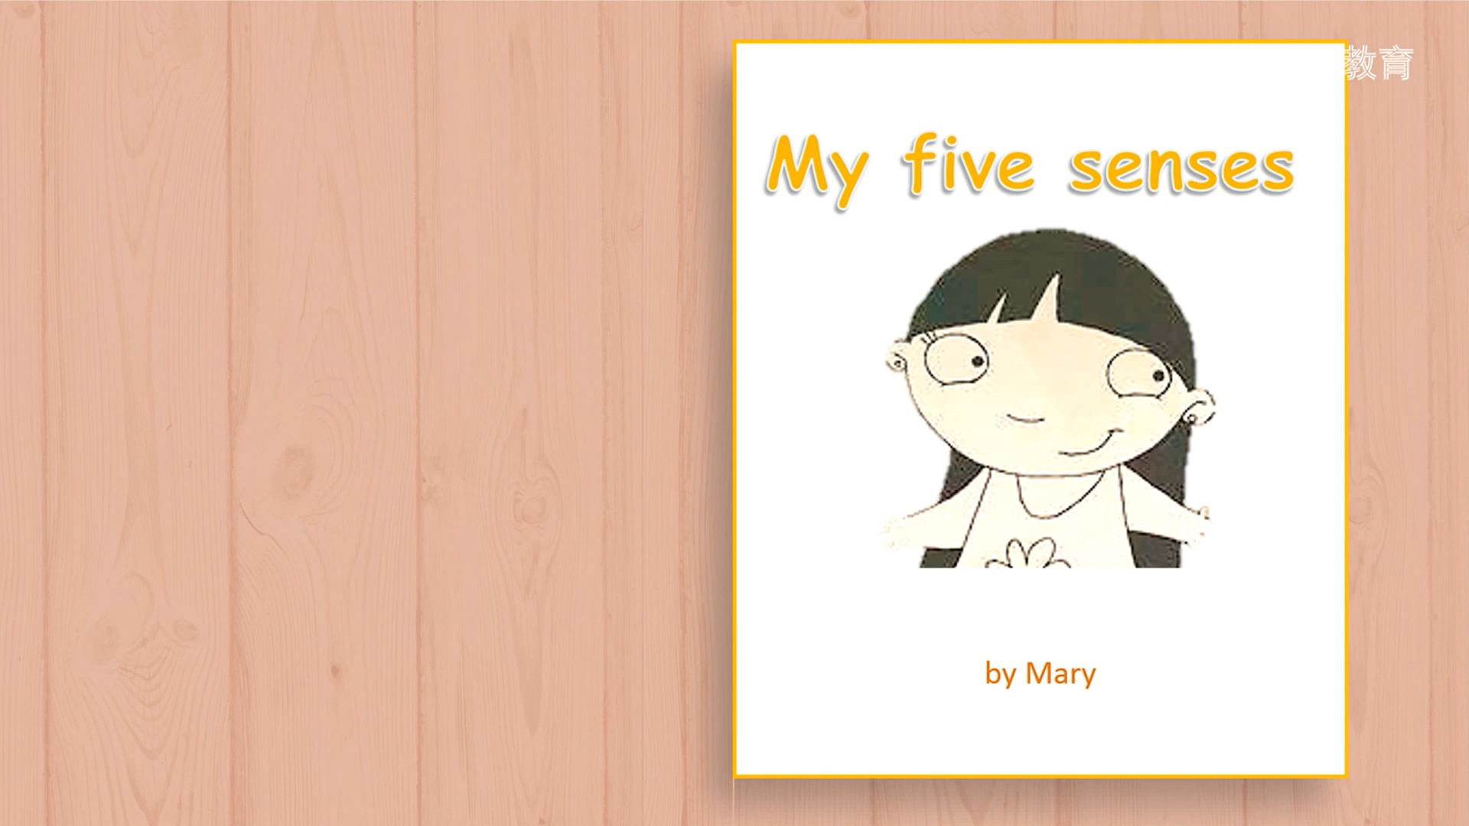**8.能够朗读绘本，发音正确、朗读流利，注意语音语调。朗读包括标题和作者。**

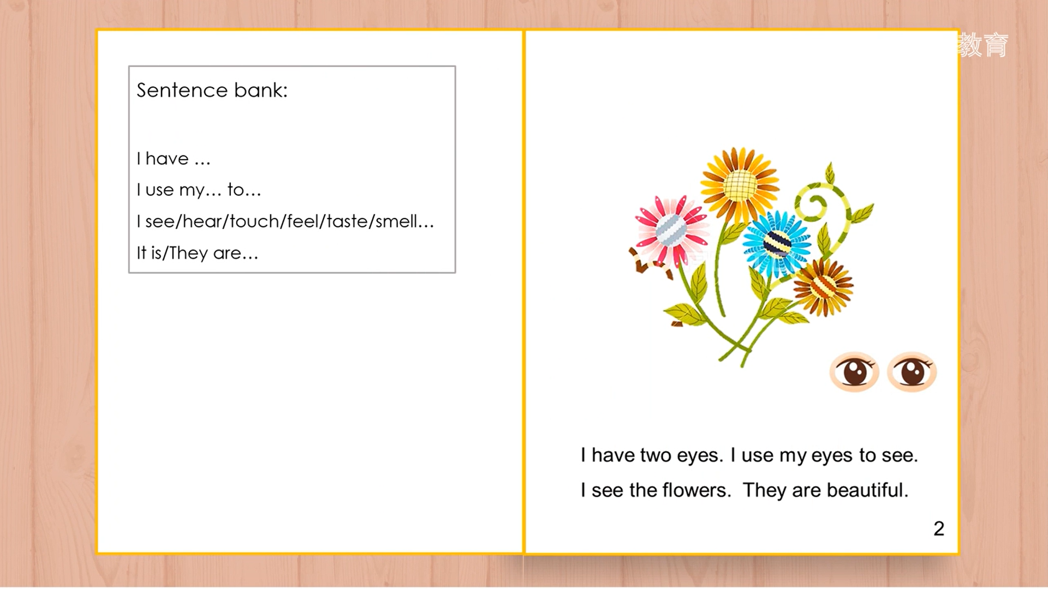

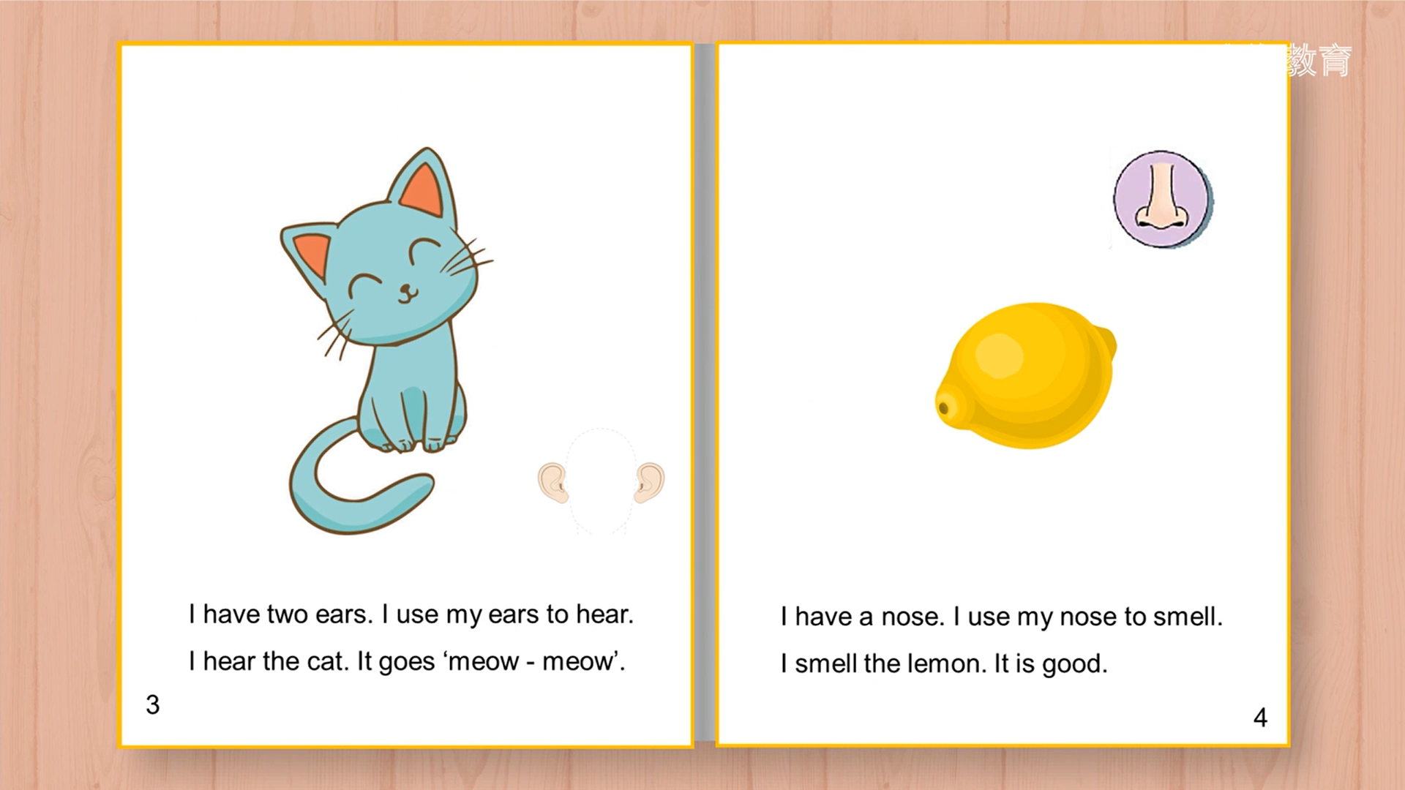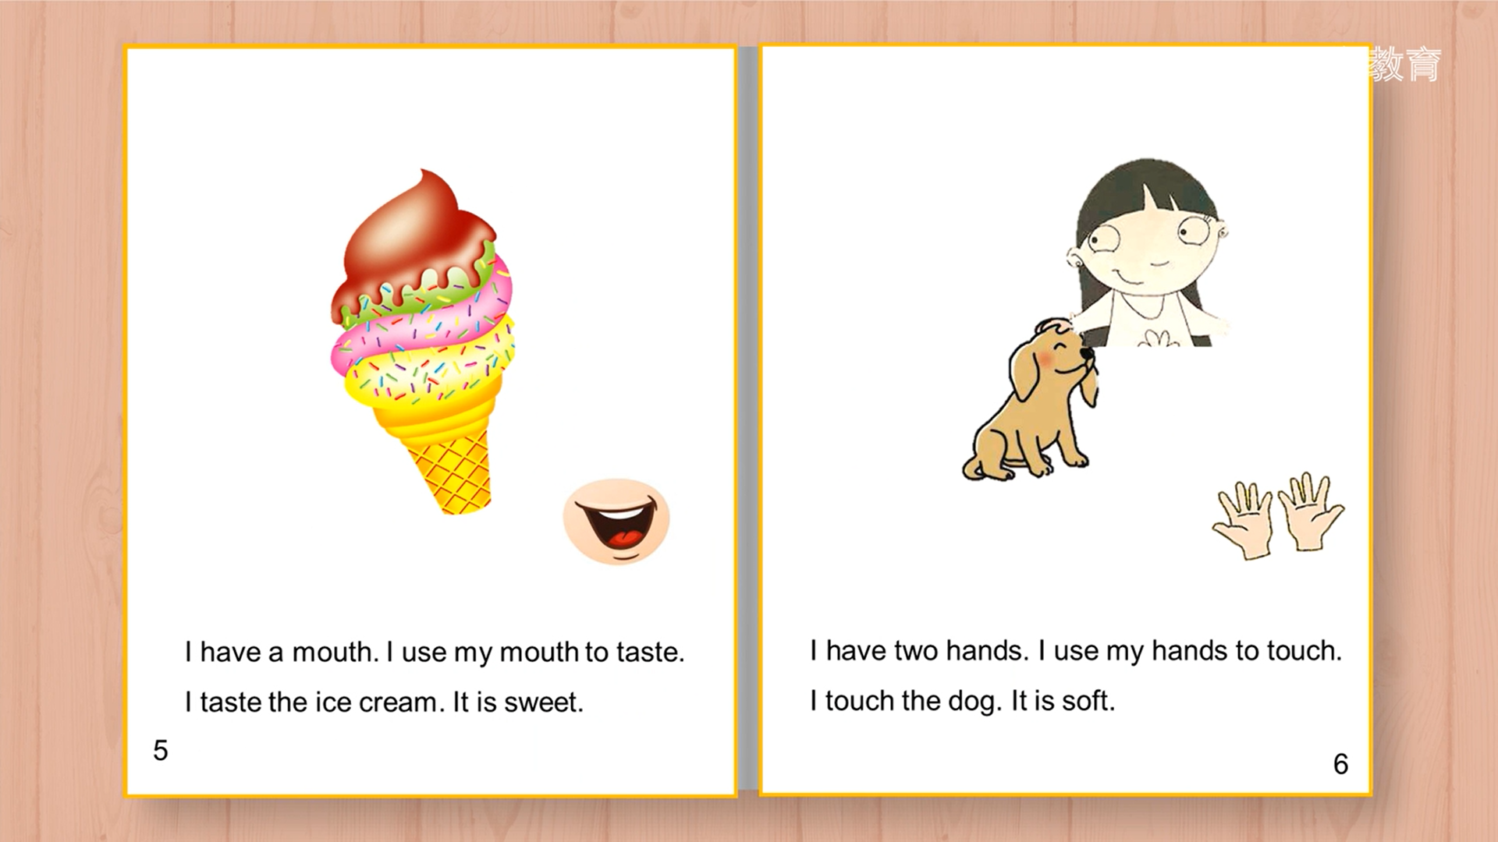

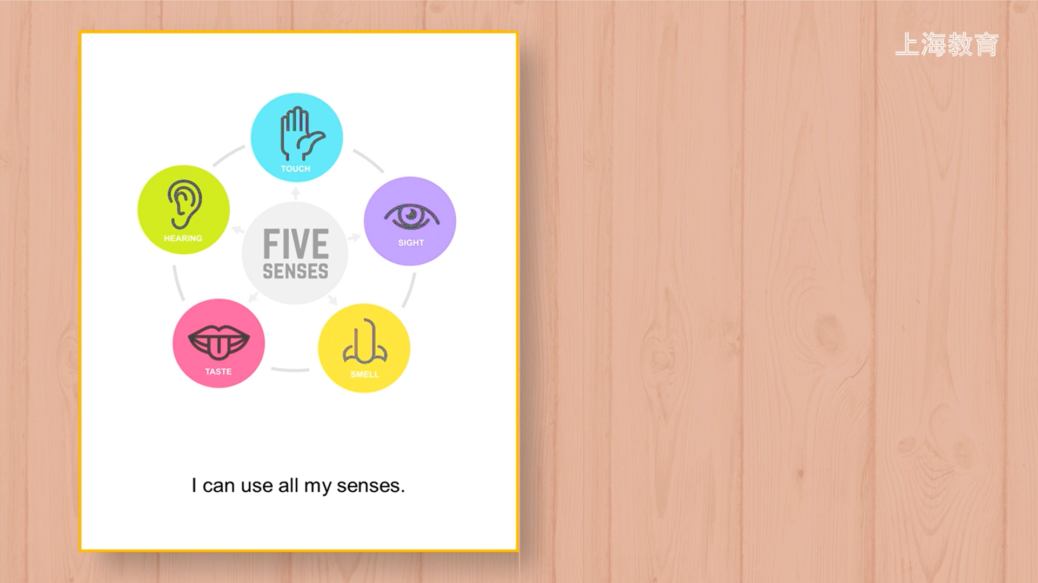

**9.尝试自己制作一本绘本，并朗读。**

**3BM1 Revision II （3.25）知识点(和周一的一样，再次认真点读一遍)**

1. What can you hear? 回答 I can hear a/an...

What do you hear? 回答 I hear a/an...

2. What can you see? 回答I can see a/an...

What do you see? 回答 I see a/an...

3. There is还是There are看后面出现的第一个单词，不可数和单数就用is，复数就用are。

There is some bread in the bag.

There is a tiger and two lions in the zoo.

There are two lions and a tiger in the zoo.

4. and连接2句句子，表示并列关系。but连接2句句子表示转折关系。

I can see a bus, and I can see some cars too. and连接，前后都是can

I can see a bus, but I can’t see any cars. but连接，前后一个是can，一个是can't。

some通常用在肯定句中，any通常用在否定句和疑问句中。例外：May I have some...?

5. by the window和beside the window意思相近，都是在窗旁。

6. ---What colour can you see? ---I can see blue. 问can you see答I can see

---What colour do you like? ---I like blue. 问...do you like答I like...

---What colour is it? ---It is blue. 问is it答it is

---What colour are they? ---They are blue. 问are they答they are

7. How many后面必须跟可数名词的复数，哪怕答句是One. How many buses? There is one bus.

回答可以直接回答数字，也可以回答There is...或者There are...

只有一个用There is one. 超过一个用There are two/ three...

8. a toy是单数，toys是复数。

a toy car是单数，这里注意复数是toy cars，toy是不变的，这里toy相当于形容词，玩具...

9. have和has的用法（看主语）

I have, you have, 祈使句用have （Mum, have a cup of tea.）

=1, 用has（Mum has a cup of tea.）

大于1, 用have

1. sit down 坐下，sit on the chair坐在椅子上
2. I have two bananas1. I have two bananas1 and two glasses2.

I have two bananas1, two glasses2 and a bag3.

连接两样东西，中间用and连接。超过两样东西，每样东西中间用逗号连接，最后2个不用逗号，而用and连接。正确抄写句子要特别注意。

12. --Touch it. How does it feel? --It is soft and rough.

--Touch them. How do they feel? --They are hard and smooth.

要摸和感觉的东西只有1个的话或者是不可数的话，就用How does it feel?

要摸和感觉的东西超过1个的话，就用How do they feel?

13. Let’s...是祈使句，肯定回答有Yes./ OK./ All right./ Great! 否定回答有Sorry, I can’t.

14. --How much is the bread? --It’s two yuan. --How much is it? --It’s ... yuan.

--How much are the apples? --They’re ten yuan. --How much are they? --They’re ...yuan.

问价格的东西只有1个或者是不可数的，用How much is it？

问价格的东西超过1个，用How much are they?

15. too有两种意思，一种是也...另外一种是太...

I don’t like the bread. It’s too hard. 这句句子中是嫌弃这个面包太硬。too后是形容词，解释为太...

--I like the pie. It’s yummy. --Me too! 这句句子中是说我也喜欢这个馅饼。too在句末，解释为也...

16. The bag is soft.(对划线部分提问)

既可以是How is the bag? 也可以是How does the bag feel?

The glasses are smooth.(对划线部分提问)

既可以是How are the glasses? 也可以是How do the glasses feel?

do和does的用法：I do, you do; =1, 用does; 大于1，用do。注意does的拼写是在do后面加es

17. What is it/ this/ that?都是回答It’s (a/an)...

18. I can touch with my fingers. with表示用...或者是和... 例如play with Danny和Danny玩

19. like表示喜欢，后面加名词的用法如下

I like cola. like+不可数 I like pineapples. like+可数复数

I like the ship. like+the+名词（单/复） I like my ruler. like+形容词性物主代词+名词（单/复）

20. Superdog和Supergirl都是名字，注意首字母大写，Superdog和Supergirl都是连起来的。

21. It’s a sweet. It’s sweet. 这句句子中第一个sweet前面有a，意思是糖，糖是可数名词，一颗糖a sweet，超过一颗糖就是sweets。句子中第二个sweet前面没有a，也没有the和形容词性物主代词，后面也没有s，单独一个sweet是形容词，解释为甜的。

22. What is it? 可以回答It’s a sweet. / It’s a lemon. 因为sweet和lemon都是可数名词。也可以回答It’s salt. / It’s coffee. 因为salt和coffee都是不可数名词。salt是盐，salty是咸的。

23. Smell意思是闻。注意和small的拼写区别，small意思是小的。

Smell it. It’s nice. Taste it. It’s sweet/ sour/ salty/ bitter.

Touch it. It’s soft/ hard/ rough/ smooth/ cold/ hot... soft软的 hard硬的 smooth光滑的 rough粗糙的

注意Smell是嗅觉，后面的形容词必须和嗅觉有关，一般用nice, smelly臭的,fishy腥的。Taste是味觉，后面的形容词必须和味觉有关,sweet, sour, bitter, salty。Touch是触觉，后面的形容词要和触觉有关, soft, hard, smooth, rough, hot, cold等。

24. Touch it. How does it feel? It’s soft. Touch them. How do they feel? They’re soft.

Smell it. How does it smell? It’s nice. Smell them. How do they smell? They’re nice.

Taste it. How does it taste? It’s sweet. Taste them. How do they taste? They’re sweet.

首先注意句子的搭配，touch和feel搭配，smell和smell搭配，taste和taste搭配，不能随意、胡乱搭配。其次，根据你要摸、要闻、要尝的东西的数量决定用左边的一句还是右边的一句。数量等于1或者是不可数的单词，只能用左边的一句（Touch it...）。数量超过1个，只能用右边的一句（Touch them...）。

25. What is it? It's salt. Is it salt? Yes, it is. / No, it isn’t.

分清楚2个问句，What is it？是特殊疑问句，直接回答是什么就可以了，可数名词单数前面加a/an，因为salt是不可数的，所以什么都不用加。而Is it salt？开头的单词是be动词，所以是一般疑问句，必须回答Yes./ No.

26. May I have some apples, please? 第一，一定要注意这是一句疑问句，所以一定要用问号。第二，虽然这是一句疑问句，还是用some，不用any，因为这句疑问句一定想要得到肯定的回答，所以还是用some。

27. Don't drink it at night, or you can’t sleep right. 这里的or不解释为或者，是“否则”的意思。

28. How much is it? It’s four yuan.

How old is he? He’s ten years old.

How many apples? There are four. How much问的是价格，回答多少钱。How old问的是年龄，回答多少岁。How many问的是数量，回答多少个。还有How many+名词复数与其它2个不同。

29. ch [ **t**ʃ ] Charlie chick chair child children China Chinese much chocolate teacher

sh [ ʃ ] ship shop short shoe shirt T-shirt sheep she shine show shout

wh [ w ] what where when why whale white

wh [ h ] who whose

1. 动词第三人称单数形式

am, is, are是 I am, you are =1, 用is 大于1, 用are

have, has有 I have, you have =1, 用has 大于1, 用have

like, likes喜欢 I like, you like =1, 用like 大于1, 用likes

**3BM1 Revision （3.25）随心练**

**I. Read and copy（读一读，正确抄写下列句子, 注意大小写及标点符号）**

touch the table kitty how does it feel its smooth

___________________________________________________________________

**II. Read and judge (判断划线部分字母发音是否相同，用T或F表示)**

1. smooth three ( ) 2. whale who ( )

3. touch rough ( ) 4. moon too ( )

**III. Read and write (读句子，写出与划线单词的同类词,使句子正确)**

1. -- Listen! What can you hear? -- I can hear a car and some _________.
2. I’m Sam. I’m a schoolboy. I can smell and _________.
3. -- Touch this box. How does it feel? -- It’s big and _________.
4. I can see with my _________. I can touch and feel with my hands.
5. -- Taste the coffee. How does it taste? -- This cup of coffee is sweet, but that cup of coffee is _________.

**IV. Read and choose （读一读，选择适当的答案）**

( ) 1. -- What can you hear? -- I can hear an _______.

A. glass B. aeroplane C. pineapple

( ) 2. -- Touch the bag. How does it ______? -- It’s rough.

A. feel B. smell C. taste

( ) 3. -- ______ the coffee, Ben. -- Hmm… It’s nice.

A. Touch B. smell C. Smell

( ) 4. -- Look! What can you ______? -- Some buses.

A. do B. hear C. see

( ) 5. – Taste the lemon, Eddie. How _______ it taste? -- It’s sour.

A. does B. do C. can

( ) 6. There _______ a chick sitting on the chair.

A. am B. is C. are

( ) 7. Touch the bananas. This one is soft, but that one isn't. It's______.

A. smooth B. rough C. hard

( ) 8. -- ______ is the pineapple? -- It’s hard and rough.

A. How B.What C. Who

( ) 9. I ______ hear a dog, but I _______ see the dog.

A. can’t … can’t B. can … can’t C. can … can

( ) 10. -- Is this _______ book? -- No, it's _______ book.

A. your ... your B. my … your C. your … my